Key Issue 8.1: Where Are States Distributed?
Pages 270-273
***Always keep your key term packet out whenever you take notes from Rubenstein. As the terms come up in the text, think through the significance of the term.
- Define state:

- List the 6 largest states in order.

- How many microstates are recognized? What do many have in common? List 6 that you can find on a map, and state where they are. (If you can only come up with 3 on your own, you’ll have to look up three more!)

- Define sovereignty:

- There is some disagreement about how many states there actually are in the world because of regions which may, or may not, actually be states. Complete the chart to demonstrate three cases.
Korea (North & South) | Western Sahara or Sahrawi Republic | People’s Democratic Republic of China (China) and/or Republic of China (Taiwan) | Senkaku/Diaoyu Islands
One state if you agree that… | One state if you agree that… | One state if you agree that… | Belongs to Japan if you agree that…
Two states if you agree that… | No state if you agree that… | Two states if you agree that… | Belongs to China if you agree that…
Key Issue 8.2: Why Are States Challenging to Create?
Pages 274-283
- Complete the graphic organizers on the topics indicated below as they related to the history of the concept of political states and their developments.
Ancient States
Medieval States

Define nation-state:

- Define nation:

Define nation-state:

Define self-determination:

- What impact did WW I and WW II have on nation-states in Europe?

- Why is Japan a fairly good example of a nation-state?

- How did Communists suppress the issues of ethnicity and nationalism? (Give several examples)

- With the fall of Communist governments in the 1990s, what kinds of problems have arisen in what places? Why?

- When the Soviet Union dissolved into 15 countries in the 1990s, the new countries were based on ethnicities. Other than Russia, they can be divided into 4 groups based on their location. Complete the chart below to indicate the countries in each group.
Baltic Region
(3 states)
Eastern Europe
(3 states)
Central Asia
(5 states)
Caucusus
(3 states)

- In the Caucusus region, there have been many problems with the new nations and ethnicities. Summarize the main problems and note specifics of regions and peoples for both Armenia and Azerbaijan.
Armenia Azerbaijain

- Note the major religion and language of each of the Baltic States.

- The ethnic divisions among the Eastern European states are blurred for what reasons?

- What did the majority of Moldovans want when they gained independence? Who opposed this?

- Have there been ethnic problems in Central Asia? If so, where? If not, why not?

- What is a multinational state?

- How many different nationalities (ethnicities) are found in the country of Russia?

- Describe the issues faced by the following multinational states
Ukraine
Georgia

Kazakhstan & Krygystan

- By definition, what is a colony?

- List the largest remaining colonies in the world and who possesses each.

- Define colonialism:

- Summarize three reasons Europeans sought colonies.

- Which country had the largest empire? Second largest?

Key Issue 8.3: Why Do States Face Threats?
Pages 284-295
- Describe the term Cold War:

- Why is the idea of two superpowers a relatively new one?

- Define balance of power:

- Describe the confrontation that occurred that exemplifies the Cold War.

- When was the United Nations established? By whom?

- Identify the reason for which membership in the UN grew significantly in each of the following periods.
1955
1960
1990s
- Who are the five permanent members of the Security Council?

- Identify some of the problems the UN faces as it attempts to operate and influence world affairs.

- Define democracy:

Define autocracy:

Define anocracy:

- What are the three areas democracies and autocracies differ?

- Why has the world become more democratic?

- Define unitary state: define federal state:

- Regarding unitary states, what are the three characteristics that tend to favor it for a country?

- Where are unitary states most common?

- Why is the federal state system more effective for larger states?

- List good examples of federal states that fulfill these conditions rather well.

- Why has tiny Belgium adopted a federal system?

- Why has enormous China adopted a unitary system?

- Define weapon of mass destruction:

- Describe the circumstances of the only use of atomic bombs in a war.

- Which countries are currently known or thought to have nuclear weapons?

- What were the effects of the Treaty on the Non-Proliferation of Nuclear Weapons?

- Describe the issues of each country suspected of pursuing weapons of mass destruction.
Libya
Iraq
Iran
Syria
- When was the European Union (EU) formed, by whom, and for what purpose?

- What are some important changes in recent years?

- Briefly explain the benefits and problems with the Eurozone.

- Describe the purpose of NATO.

- Describe the purpose of the former “Warsaw Pact” countries.

- By definition, what is terrorism?

- List typical criteria of acts of terrorism.

- Why is terrorism different from other acts of political violence?

- List two places in which Americans were attacked by foreign terrorists and two places by domestic terrorists in the late 20th century and early 21st century.
Foreign Domestic

- Identify each of the following terms as they relate to the terrorist organization known as Al-Qaeda.
  - Osama bin-Laden:

  - Afghanistan:

  - Paris:

- Briefly outline the background and actions of the following terrorist organizations.
Boko Haram | Taliban | Islamic State (ISIS/ISIL)

- In what ways do groups like Al-Qaeda or Islamic state, their religious and political views, and their methods pose a challenge to Americans?

Key Issue 8.4: Why Do States Have Distinctive Geographic Structures?
Pages 296-307
- Define boundary:

Define cultural boundary:

Define geometric boundary:

Define Physical boundary:

- What are two types of cultural boundaries that have often been used? Give an example of each type of cultural boundary and describe.

Case Study: Cyprus
- Bullet in the most significant facts regarding the boundary and ethnic situation in Cyprus. Annotate the map as appropriate.

- Complete the chart below to describe the advantages of each type of physical boundary.
Deserts | Mountains | Water

- What is the Law of the Sea and what three types of boundaries does it identify?

- Provide examples of geometric boundaries for each of the following.
North America | North Africa | South Pole
Shapes of States
- Complete the chart based on your reading. The text gives examples of African countries that you should provide (map pg. 280).
Shapes |  | Examples
Compact | Greatest advantage…
Elongated | Biggest problem…
Prorupted | Reason for prorupting the shape of a state…
Perforated | How is the perforator state dependent on the “perforatee”?
Fragmented | Different kinds…

- Define landlocked state:

- Where are most of the world’s landlocked states? Why there?

- What problems do landlocked states have?

- Shade and label all 15 of Africa’s landlocked states. (Use Figure 8-33 to help)

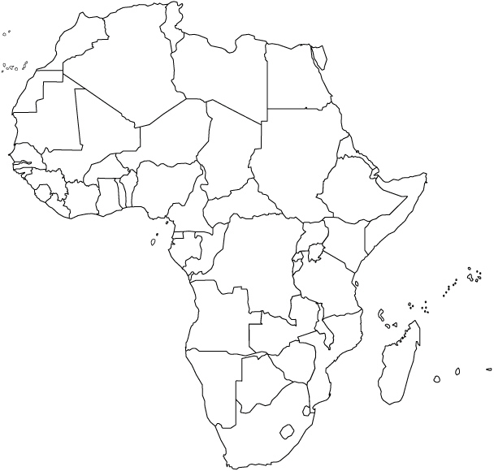

- Why are boundaries of legislative districts occasionally redrawn? How often is this done in the U.S.?

- What is gerrymandering?

- What are the three types of gerrymandering? Explain them.

- How is gerrymandering combined with ethnicity for political use?

- How is this type of boundary redrawing different in the U.S. than in Europe?

