Key Issue 7.1: Where Are Ethnicities Distributed?
Pages 232-241
***Always keep your key term packet out whenever you take notes from Rubenstein. As the terms come up in the text, think through the significance of the term.
- Define ethnicity:

- Define race and describe its features:

- What is racism?

- What are the three most numerous ethnicities in the United States?

- What is the “problem” with the way the U.S. Census Bureau defines “Asian”?

- What is the difference between “African-American” and “black”?

- How does the U.S. Census Bureau consider Hispanic/Latino?

- Provide an example to illustrate that African-Americans or Hispanics in the U.S. are more urbanized.

- In the chart below, explain where each ethnic group is clustered in the United States.

Hispanics
Asian American
African American
Indigenous Peoples

- Define ethnic enclave:

- Define ethnoburbs and provide an example.

- Provide an example of urban ethnic enclaves in the United States.

Key Issue 7.2: Why Do Ethnicities Have Distinctive Distributions?
Pages 242-249
- Complete the chart below to summarize the historic migration patterns of African Americans.
Forced Migration  Pgs. 242-43 | Interregional Migration  Pg. 244 | Intraregional Migration  Pg. 245

- Describe the following concepts dealing with the geography of race:
  - “White Flight”

  - Blockbusting

  - Redlining

  - “Separate but Equal”

- Outline how the civil rights movement has changed in the U.S.

- Define apartheid:

- Explain the key components of the apartheid system:

- Complete the following timeline of South African history and identify on the map the 10 homelands (figure 7-32).
1652 –

1795 –

1948 –

1991 –

1994 -

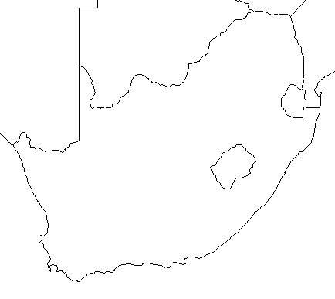

- When the British ended colonial control of South Asia in 1947, how was the region divided politically, and how was the region divided ethnically (religiously)?

- How many people found themselves on the “wrong side of the boundary” in the 1940s?

- How many Muslims migrated from India to West Pakistan (Pakistan, today)?

- How many Muslims migrated to East Pakistan (Bangladesh, today)?

- How many Hindus migrated from East and West Pakistan into India?

- What happened to many of the refugees as they traveled?

- Why is the region of Kashmir a problem?

- Discuss some of the issues that the Kurds suffer from.

Key Issue 7.3: Why Might Ethnicities Face Conflicts?
Pages 250-255
- Define nationality:

- Though they are very similar, use the chart below to show how nationality differs from ethnicity.
Ethnicity | Nationality
- Explain the difference between ethnicity and nationality in the British Isles.

- What is nationalism?

- How do nations and states foster it?

- In the chart below, bullet key points about ethnic diversity in West-Central Asia.
Pakistan | Iran | Afghanistan | Caucasus

- In the chart below, bullet key points about ethnic diversity in Western Asia.
Turkey | Iraq | Syria | Lebanon

Key Issue 7.4: Why Do Ethnic Cleansing and Genocide Occur?
Pages 256-265
- Define ethnic cleansing:

- Define geonocide:

- How is ethnic cleansing different than normal warfare?

- Describe how Europe was impacted by genocide & ethnic cleansing.

- Describe the conflict against the Rohingya in Myanmar.

- List important/interesting facts regarding the creation of the post-WWI country of Yugoslavia.

- What ethno-political problems did the country face after the death of Tito in the 80s and the fall of Communism in the 90s?

- What country controlled Kosovo?

- What ethnic group lives in Kosovo (and %)?

- With the breakup of Yugoslavia, what began to happen in Kosovo?

- How did the U.S. and U.N. respond?

- Why did Serbs and Croats in Bosnia (aka Bosnia-Herzegovina) ethnically cleanse themselves of Bosnia Muslims?

- What was agreed upon at the accords signed between these rival ethnicities in Dayton, Ohio in 1996?

- Who got the best deal? Who got the worst deal? Explain.

- Define balkanized:

- Define balkanization:

- Since peace has come to the Balkan Peninsula, why does the author of the textbook consider it to be “in a tragic way”?

Ethnic Cleansing & Genocide in Africa
- What impact did European countries have on the states of Africa?

- Make notes on major issues in each of these ethnic conflicts as well as shade and annotate the map as necessary.
Sudan civil wars:  Darfur-  South Sudan- | 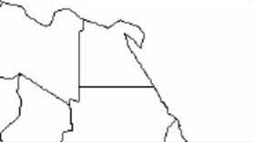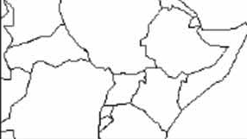
Abyei- |  | South Kordofan and Blue Nile-  Eastern Front-

- Give the historical background of the two rival groups in Central Africa’s countries of Rwanda and Burundi.
Hutus | Tutsis

- What is the situation in Rwanda and Burundi today?

- What is the situation in the Congo?

