Key Issue 5.1: Where Are Languages Distributed?
Pages 148-157
- Define language:

- How do languages act a either centripetal or centrifugal forces?

- How can language be used to show migration patterns? What types of diffusion spread languages?

- Define the following terms
institutional language:

developing language:

vigorous language:

threatened language:

dying Language:

literary tradition:

- Define the following terms and label the picture with the correct term from page 153 (figure 5.9).
language family:

language branch:

language group:

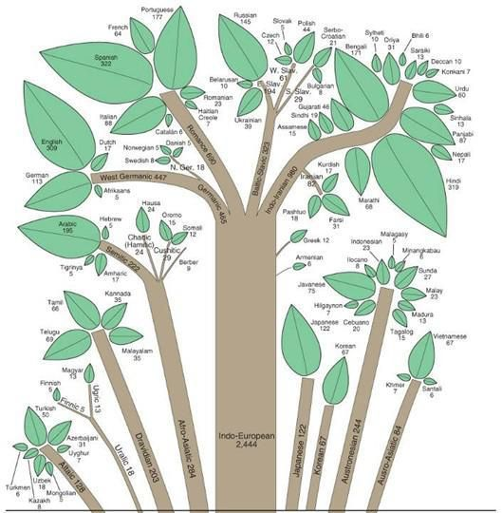

- Identify the two largest language families and the percentage of people who speak a language in that family.

- Indo-Iranian Branch: Make 2 bullets charts from the reading.
Indic Group (Eastern) | Iranian Group (Western)

Germanic Branch
West Germanic Group | North Germanic Group
⬇  ⬇

- How did Russian become the most important East Slavic language?

- What is the most important West Slavic language?

- Describe the controversy between Czech and Slovak languages under Czechoslovakia’s government?

- The four most contemporary Romance languages are _________________________, ________________________, _________________________ & ______________________________.

- Describe two language families from East Asia.

- Describe Dravidian family from the Other Asian families.

- Describe both Afro-Asiatic and Niger-Congo language families.
Key Issue 5.2: Why Do Languages Diffuse?
Pages 158-163
- How did Latin languages diffuse in Europe? What happened to the native languages?

- Define Vulgar Latin:

- What is the name of the (theoretical) common ancestral language of the Indo Europan languages? Why is its existence difficult (impossible) to prove?

- Contrast the two views of the origin of this language in the chart below (page 159).

“Kurgan” Theory | Renfrew Hypothesis

- What three European people originally came together to form the English people and English language?

- What two subsequent invasions added additional words to the evolving English language?

- How has expansion diffusion occurred with English? Give four examples.

- What is a lingua franca? What have been the benefits and problems with English as a lingua Franca?

- Why is much of the internet in English? Why might this be problematic?

Key Issue 5.3: Why Do Languages Vary Among Places?
Pages 164-173
- Does the United States have an official language? Why or why not?

- Describe the three informal languages (Franglais, Spanglish, Denglish).

- Define pidgin language:

- Dialects are defined as “regional variations of a language” and are distinguished by three things. What are they?

- Provide information for the three ways that American and British English differ-
Vocabular:

Pronunciation:

Spelling:

- Define standard language:

- What is the standard language for of English? Where did it come from (3 cities)? How was it diffused throughout Britain?

- What is an isogloss?

- How did the three early dialect regions of the U.S. impact the current distribution of dialects?
North:

South:

Midland

- What is African America Vernacular English?

- Define creolized language:

- Why is it difficult to distinguish individual languages from dialects?

- What issues are faced with Catalan-Valencian-Balear? Occitan?

- How have governments promoted the standardization of languages?
French-

Spanish-

Portugese-
- What impact does gender have on language?

- Prepare detailed notes with bullets and notations on the maps regarding the following case studies:
Switzerland: Institutionalized Diversity (Figure 5-36)
Notes:

Belgium: Barley Speaking (Figure 5-37)
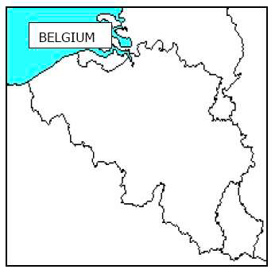
Notes:

Nigeria: Spatial Compromise (Figure 5-3)
Notes:
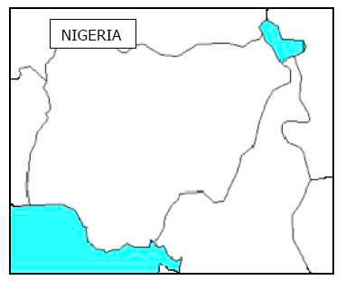
- Describe the situation of Canada’s Bilingual Autonomy.

Key Issue 5.4: Why do Languages Survive or Perish?
Pages 174-181
- What is an endangered language?

- What is an isolated language?

- What is an extinct language?

- Complete the chart below by taking notes on the various languages/countries & the issues they are facing.
Australia –

New Zealand –

Basque –

Icelandic –

Brythonic Celtic- (Welsh, Cornish, Breton, Irish Gaelic, Scottish Gaeolic)

- How do we see languages growing? Provide example.

- How do we see languages being revived? Provide example.

- Describe at least one new language that has emerged.

