Key Issue 3.1: Where Are Migrants Distributed?
Pages 80-87
- What geographer wrote about the principles of migration? What are the three groups of his principles?

- Using figure 3-1, briefly state what one would expect to occur, in terms of migration, in each stage of the demographic transition model, as it is applied to a migration transition.

MIGRATION TRANSITION
As Applied to the Demographic Transition Model
Stage 1 | Stage 2 | Stage 3 & 4

- Migration may be classified as either international or internal. What is the difference?

- What types of push factors are usually responsible for voluntary migration?

- What types of push factors are usually responsible for forced migration (refugees)?

- Define interregional migration:

- Define intraregion migration:

- What is the difference between immigration and emigration? From 1990-2017 where are most international migrants from and what country is the primary destination for those migrants?

- Read the section, Migration Patterns in Europe on page 85, and then make 5 summary statements regarding migration patterns.

- Finish this statement: The world’s third most populous country (the U.S.) is inhabited overwhelmingly by…

- Annotate the graph below from your reading of pages 82-83. Be sure to label all “peaks” and “valleys” as to where immigrants came from during that time or why there was a decline in immigration.
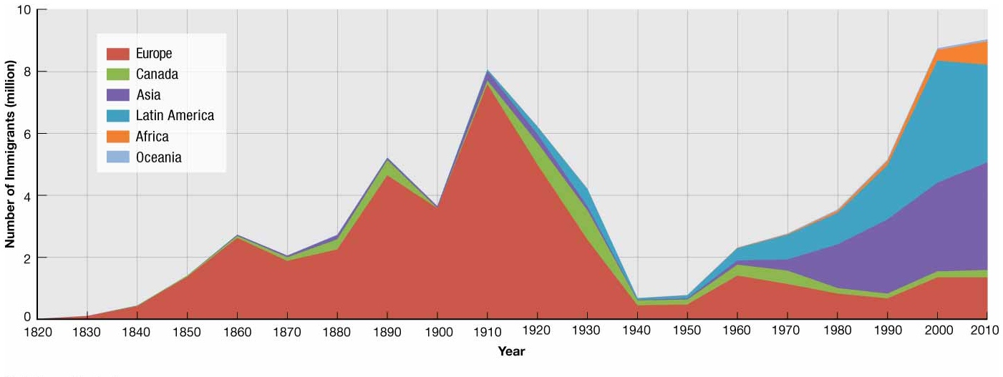
- What are the four countries that sent out the most immigrants from Asia in recent years?

- What caused immigration from Latin America to the United States to increase?

- Although the reasons people leave their countries to immigrate to the U.S. have not changed over time, what has changed here in the U.S.?

Key Issue 3.2: Where Do People Migrate Within Countries?
Pages 88-93
- What is the most famous example of large-scale interregional migration in the U.S.?

- What is the “population center” (see Figure 3-14)?

- What was the first intervening obstacle (check your vocab list) which hindered American settlement of the interior of the continent?

- What developments in transportation eventually encouraged settlement to the Mississippi?

- Why was settlement of the Great Plains slow to come with settlers passing it by for California and the west coast?

- How did the railroads encourage settlement of the American interior?

- For what two reasons have people been migrating to the South in recent years?

- Use figure 3-16 on page 89 to calculate the net growth or loss of U.S. regions for 2016-17. Name the region on the map and place the appropriate number in each region.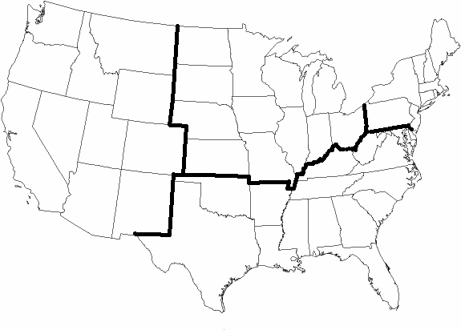
- Make appropriate notes in the chart below on 5 specific examples/case studies of interregional migration.
Russia
Where? | Why?
How?

Canada
Where? | Why?
How?
China
Where? | Why?
How?

Brazil
Where? |  | Why?
How?

- Define/describe each of the following terms, and summarize a single, important fact about its occurrence in the U.S.
 | Urbanization | Suburbanization | Counterurbanization
Definition
Significant Fact
in U.S.
Key Issue 3.3: Why Do People Migrate?
Pages 94-101

- What are push factors and pull factors?

- Complete the chart below with specific examples of push and pull factors and where people are being pushed from and pulled to. Pages 94-99
 | Push Factors | Pull Factors
Political
Environmental
Economic

- Explain why Southwest Asia is a major destination for migrants.

- Complete the following chart from the reading about migrants.
Characteristics of Migrants
Gender
Age

Key Issue 3.4: Why Do Migrants Face Obstacles?
Pages 102-108
- How does the U.N. classify countries based on their immigration policies?

- What are unauthorized immigrants? How is the term undocumented immigrants different?

- Where do most undocumented immigrants in the U.S. come from? What is their destination? What percent of the U.S. workforce are they?

- What did the Quota Act (1921) and the National Origins Act (1924) do?

- How did the Immigration Act of 1965 change the existing quota laws?

- How was immigration law further changed in 1978? And presently?

- U.S. immigration law gives preferences to groups. Identify those preferences.

- Define brain drain:

- Define family based migration:

- Complete the following chart about the four major elements of immigration law in the U.S.
Immigration Law
Border Patrol
Workplace
Civil Rights
Local Initiatives

- Describe the European guest worker programs.

- What are some of the attitudes of Europeans towards immigrants?

