**Key Issue 2.1: Where are People Distributed?**

***Pages 48-53***

*\*\*\*Always keep your key term packet out whenever you take notes from Rubenstein. As the terms come up in the text, think through the significance of the term.*

1. What are the three reasons that make the study of population geography so important?
2. 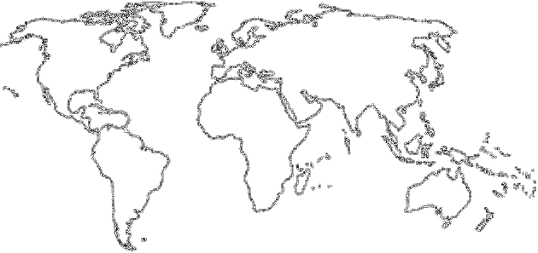The world’s population is highly clustered, or concentrated in certain regions. FOUR major population concentrations are identified in the text. **Shade** and **label** the areas of these concentrations on the map in **red**. TWO smaller concentrations, or emerging clusters, are also identified. **Shade** and **label** these areas on the map in **blue**.
3. In the boxes below, make note of significant facts, features, countries involved, and characteristics of the **four** most important population concentrations and **two** secondary ones.

|  |  |  |  |
| --- | --- | --- | --- |
| **EAST ASIA** | | **SOUTH ASIA** | |
| **SOUTHEAST ASIA** | **EUROPE** | | **EASTERN NORTH AMERICA**  **WEST AFRICA** |

1. Define ***ecumene:***
2. What would ***non-ecumene*** mean?
3. In the table below, list the four “lands” which are sparsely populated on earth. For each region, explain the reason which makes it inhospitable for human habitation.

|  |  |
| --- | --- |
| **Sparsely Populated Land** | **Reason(s) for Inhospitality** |
| Dry Lands |  |
| Wet Lands |  |
| Cold Lands |  |
| High Lands |  |

1. Use the maps on page 47 to prepare a sketch map that shows **non-ecumene** and **very sparsely inhabited lands.**
2. Define ***arithmetic density:***
3. Define ***physiological density:***
4. What occurs when the rate of physiological density increases?
5. Define ***agricultural density:***

**Key Issue 2.2: Why Is Population Increasing?**

***Pages 54-59***

1. Define ***natural increase rate (NIR)***:
2. What is the NIR today?
3. When did the global NIR peak, and what was it?
4. About how many people are being added to the world’s population each year?
5. Define ***doubling time:***
6. In what world regions is most growth occurring?
7. Define ***crude birth rate (CBR)***:
8. Define ***total fertility rate (TFR)****:*
9. What is the global “average” TFR?
10. Note the rates and locations of the global “highs and lows” in TFR.
11. Define ***Infant mortality rate (IMR):***
12. Define ***crude death rate (CDR)***:

***\* This is an ESSENTIAL ISSUE!!!! You will be required to draw and explain the DTM!!!!! You will also need to be able to read population pyramids and connect them to stages of the DTM!\****

1. The **demographic transition** is a ________________________ with several

___________________ and every __________________________ is in one of the stages.

1. Fill in the chart below with characteristics describing each stage in the demographic transition model (CBR, CDR, NIR, etc.). Characterize the amount of growth of each stage (low, high, decreasing (aka moderate) etc.). Also, include the country identified in each stage and briefly describe how it got to that stage.

|  |  |  |  |
| --- | --- | --- | --- |
| **Demographic Transition Model** | | | |
| Stage 1 | Stage 2 | Stage 3 | Stage 4 |
|  |  |  |  |

1. In what sense can we say that the first break came to **different world regions** for **different reasons** and in **different ways**?
   1. It came to Europe and North America…
   2. It came to Africa, Asia, and Latin America…

**Key Issue 2.3: Why Does Health Vary by Region?**

***Pages 60-67***

1. Describe the different trends between developed countries and developing countries regarding medical facilities and health care costs.
2. What can lead to a higher ***maternal mortality rate*** in developing countries? In the United States?
3. What are the issues associated with the ***sex ratio*** of a population*?*
4. The shape of a pyramid is primarily determined by what demographic rate?
5. What issues must countries deal with as a result of the **“graying”** of a population?
6. What is the ***dependency ratio?***
7. What age groups are categorized as **“dependent”**?
8. What is ***epidemiologic transition?***
9. Complete the table below with notes on the stages of epidemiologic transition:

|  |  |  |  |
| --- | --- | --- | --- |
| **Stage 1** | **Stage 2** | **Stage 3** | **Stage 4** |
|  |  |  |  |

**Key Issue 2.4: Why Might Population Change in the Future?**

***Pages 68-75***

1. What predictions does the United Nations make regarding the future population of the planet?
2. What would characterize a possible stage 5 of the DTM? Which countries could become possible stage 5?
3. In the chart below, summarize/bullet key points of India’s and China’s population policies

|  |  |
| --- | --- |
| **India** | **China** |
|  |  |

1. The CBR has declined rapidly since 1990. **Identify** the **two** strategies that have been successful in reducing birth rates and **explain** **why** they have been successful.



1. Describe the three reasons for a possible stage 5 of the epidemiologic transition?
2. Complete the table below to describe the views/theories of various population theorists:

|  |  |  |
| --- | --- | --- |
| Thomas Malthus | Neo-Malthusians | Critics of Malthus |
|  |  |  |

1. Where has Malthus’s theory proven right?
2. In what ways was Malthus mistaken?