Key Issue 13.1: Why Are Cities Challenging to Define?
Pages 462-467
***Always keep your key term packet out whenever you take notes from Rubenstein. As the terms come up in the text, think through the significance of the term.
- Define Central city:

- What are the three basic characteristics of a city?

- What is the functional area of a city?

- What does the MSA encompass?

- What is a micropolitan statistical area?

- Define the following:
urban area:

urbanized area:

urban cluster:

- What is a Megalopolis?

- What is the Megalopolis from Boston to D.C. called (figure 13-2)?

- Define the term CBD in one word.

- List four characteristics of a typical CBD (pg. 464, left column).

Using your knowledge of services from chapter 12, define each term and give an example of a typical downtown shop with that characteristic.
- High Threshold

- High Range

- Why are these shops decreasing in the CBD?

- Another type of shop in the CBD are those which provide services to downtown workers. Give three examples.

- Why are these shops increasing?

- Why is there intense competition for land in CBDs?

- What is happening to the old manufacturing districts in American CBDs?

- Regarding residential uses – identify a factor pushing them out of the CBD and another that is pulling them elsewhere.

Pushing… | Pulling…

- Describe how the intense land use of CBDs has created expansion of the CBD “above” and “below” in order to maximize the small space of the downtown?

- How is the underground utilized in cities?

- How is “land use” distributed within a typical skyscraper?

- What is the only major U.S. city without skyscrapers?

Key Issue 13.2: Where Are People Distributed in Urban Areas?
Pages 468-479
- Read the following section of this key issue and for each of the three models, annotate the diagrams below and do the following:
- Identify the model by name
- Name the geographer(2) who developed the model
- Define the model
- Identify and label key parts of the model
- Bullet important characteristics and/or features of the model

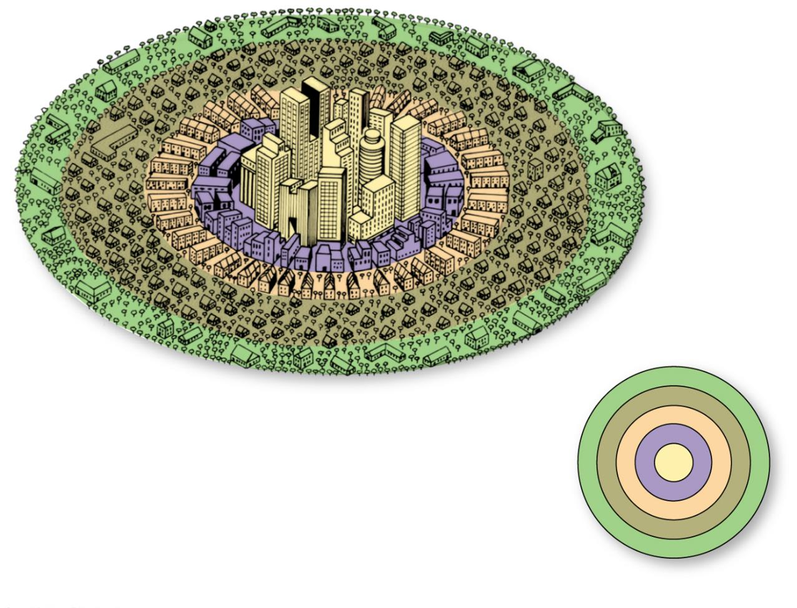

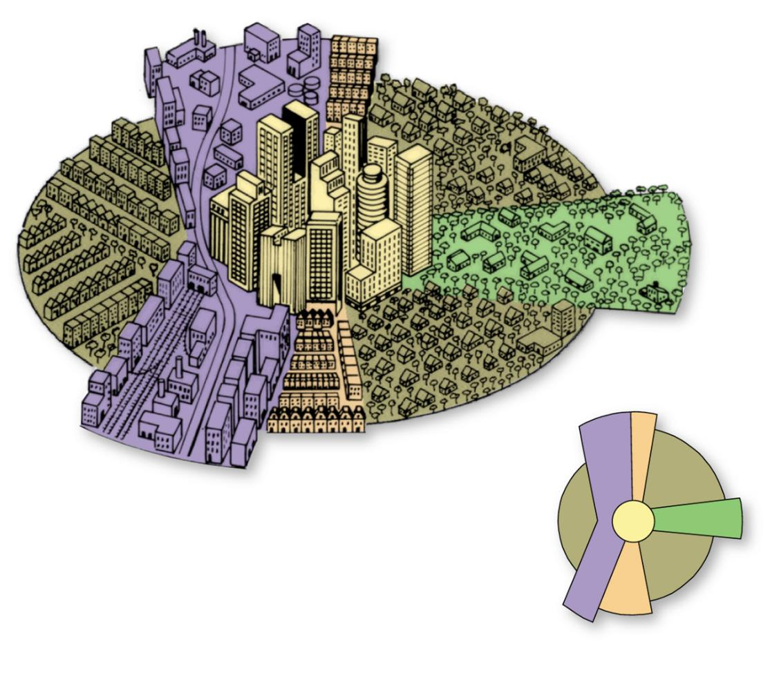

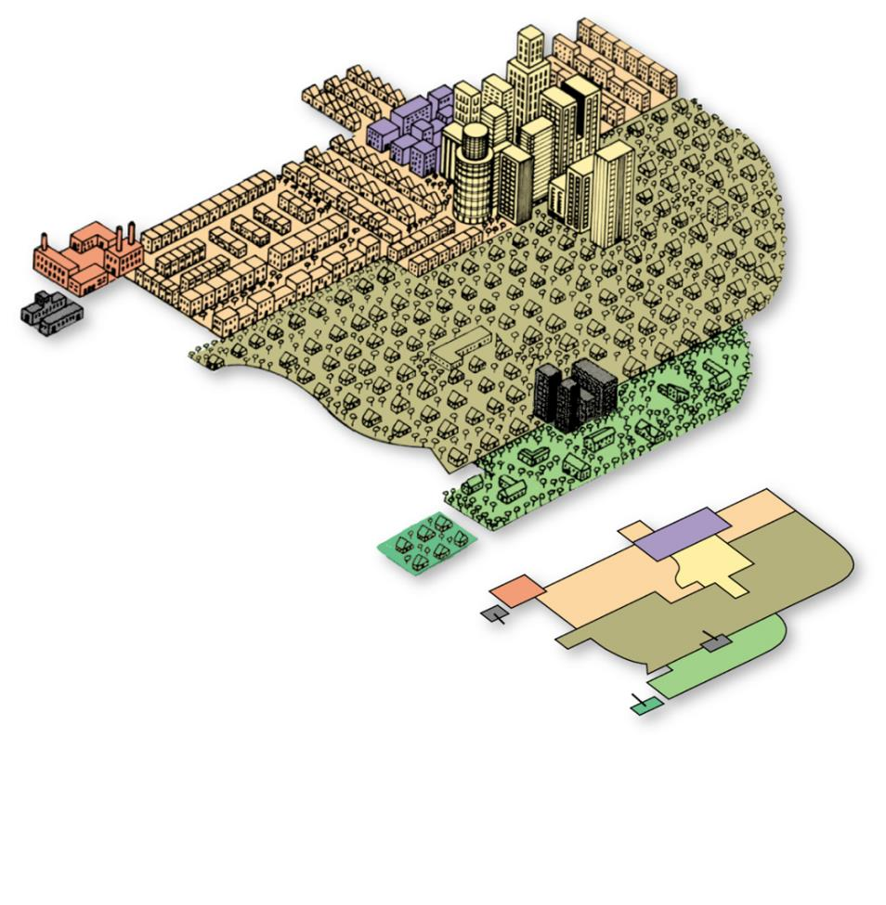

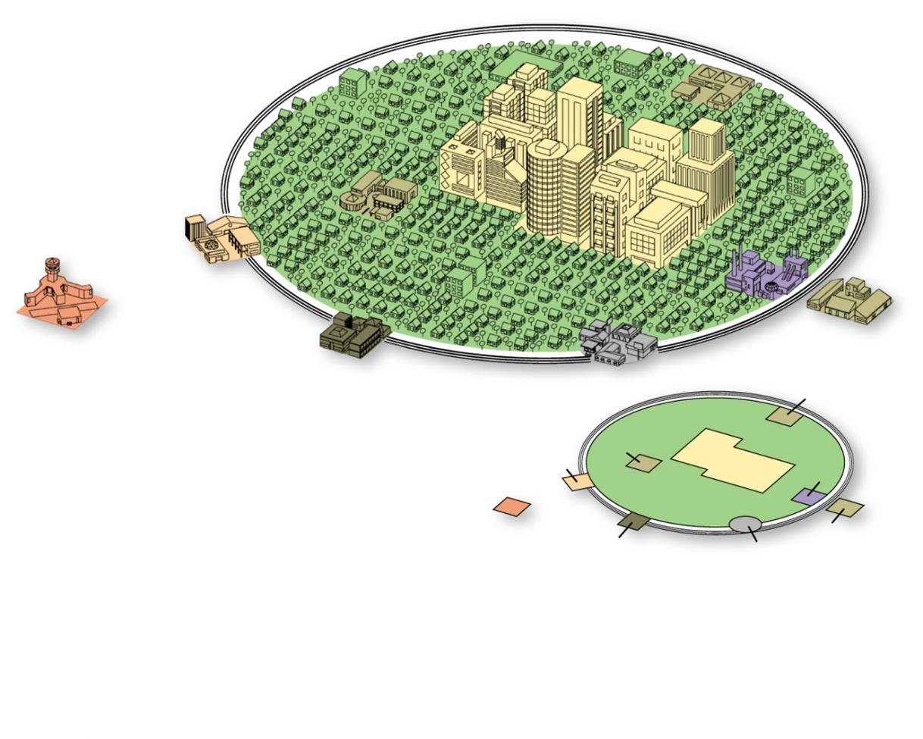

- Define edge city:

- What are census tracts?

- What three types of data are reported by the U.S. Census Bureau regarding the population of each census tract?

- What is social area analysis?

- What are the criticisms of using these models?

- List four ways that a European CBD differs from a North American CBD.

- Provide one observation about the conditions of European suburbs, where the poor live, based on each of the models.
Concentric Zone model | Sector model | Multiple Nulcei model

- Cities in Africa, Asia and Latin America resemble European cities in their structure. This is not a coincidence because….

- How did the Laws of the Indies affect Spanish cities in Latin America?

- Colonial cities often contained a new “European sector” to the side of the pre-colonial city. Contrast their various elements in the table below.
“Old Quarters” – pre-colonial city | “European district” – colonial addition
- How has the concentric zones model been applied in developing countries?

- Define informal settlements.

- What other terms are used to refer to these settlements?

- What are the causes of squatter settlement?

- Describe services and amenities in a typical squatter settlement.

- Explain how the Latin American City Model in the chart below represents the sectors model in developing countries.
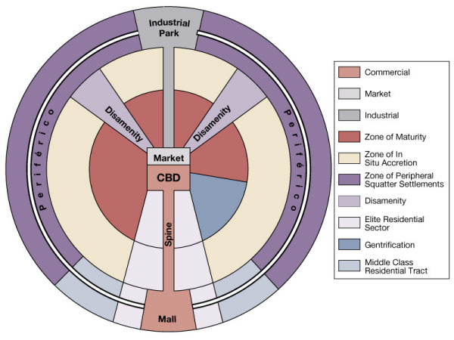
- How might the multiple nuclei model apply in a developing country?

- Briefly describe the three stages of Mexico City’s development.
Pre-European origin | European Colonial period | Postcolonial independence

Key Issue 13.3: Why Do Urban Areas Expand?
Pages 480-489
- Define suburb:

- What is annexation?

- What is required before an area can be annexed by a city?

- In the past, why did peripheral areas desire annexation?

- What has changed?

- Define sprawl:

- What is meant by the statement: the “periphery of U.S. cities looks like Swiss cheese”?

- Describe the density gradient of an urban area.

- In what two ways has the density gradient changed in recent years?

- What is the function of greenbelts in the U.K.?

- What is smart growth?

- Describe how “smart growth” laws have been designed in the following states?
Maryland | Oregon & Tennessee

- In what two ways are suburban areas segregated?

- What is a zoning ordinance?

- What impact has this had on U.S. suburbs?

- Bullet important information regarding:
Suburbanization of Consumer Services
Suburbanization of business services and factories

- Identify two ways in which the U.S. Government has encouraged the use of motor vehicles by its citizens.

- List four ways in which public transportation is better than an automobile.

- What is rush hour and how much of a city’s traffic does it account for?

- Briefly describe what has happened (or is happening) to public transportation
Historic use in the U.S.
Recent trends in usage in the U.S.
Challenges facing public transit
Key Issue 13.4: Why Might Cities Be More Sustainable?
Pages 490-499

- Define underclass.

- List and briefly describe four specific social problems of the underclass.
Job skills | Challenges for families | Challenges to health & Safety | Services

- Define gentrification:

- What three groups are attracted to gentrified areas and why?

- Why has gentrification been criticized?

- How has gentrification revived consumer services in the inner city?

- Give three examples of some thriving CBDs that have been revived and explain why they’re doing well

- Complete the chart below regarding public housing.
Public Housing
Who builds & maintains it?
Percentage in the U.S.
Reasons high-rise public housing is unsatisfactory
How are recent public housing projects different?

- Describe the four methods employed by governments to reduce traffic congestion?

- What is the upside of fully autonomous vehicles?

- What is the issue with dependence on electric powered vehicles to reduce pollution and fossil fuel dependency?

- Summarize how each of these five geographical concepts apply to China’s urban places.
Place | Region | Scale | Space | Connection

